Press release –
International Women’s Day
Cairo, 9 March 2023

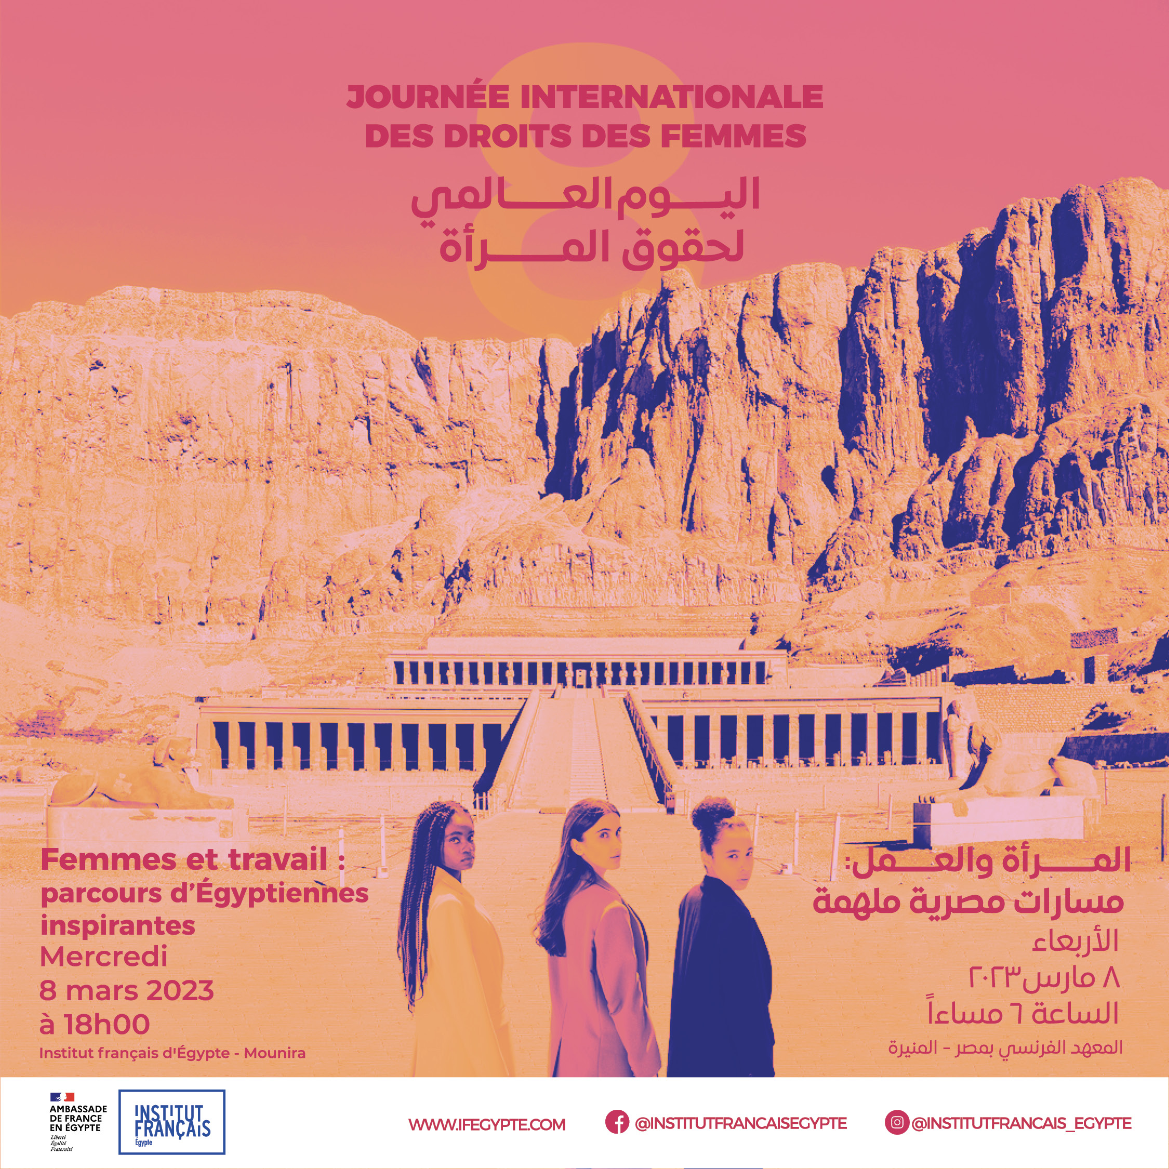
"Women's rights are a year-round issue, not only on March 8", declared the French Ambassador to Egypt, Marc Baréty, during the special evening organized at the French Institute to celebrate the International Women’s Day.

As every year, the International Women's Rights Day on 8 March was an opportunity for France to reaffirm its commitment alongside Egypt in favour of equality between women and men.
"March 8 is an opportunity to underline the importance of a continuous commitment to gender equality, to measure the progress made, but also to recall the challenges that remain to be met and in the face of which a collective effort, guided by an ambitious and voluntarist policy, is essential", declared the French ambassador to Egypt during his opening speech.

This year, the French Embassy and the French Institute of Egypt organized a round-table discussion on women in the labour market in Egypt.

Moderated by Dalia Chams, journalist at Al-Ahram hebdo, the event was a great success and was full house!

UN Women, a key partner of the event

Christine Arab, UN Women Country Representative in Egypt, chose the French Institute of Egypt to celebrate 8 March.

In her opening speech, Christine Arab stressed that "the digital divide is the new face of gender inequality", while reminding us that " the digital age represents an unprecedented opportunity to eliminate all forms of disparity and inequality”.

Four women inspiring Egyptian society

Four inspiring women, who have made a career in professional sectors where women are still under-represented, came to share their experiences.

Dr. Hoda Abou Shady, Professor of nuclear and theoretical physics at the faculty of Science – Cairo University, spoke about the obstacles she had to overcome working in a male-dominated field and encouraged young Egyptian girls to pursue a career in science. For her, "women’s economic independence is at the core of their empowerment" and she regrets that the subject of wage inequality remains to this day a key issue on which societies seem to make the least progress.

Hilda Louca, entrepreneur, founder, and executive director of the 'Mitcha' platform which is dedicated to local fashion designers, ranked among the 100 most powerful women in the Middle East by Forbes 2023, discussed the opportunities offered by the digitalisation of the labour market and the emergence of female entrepreneurship, as drivers of employment for the future. As the only woman present on Sharktank today, she brings a different voice to the debate. This is also what she is trying to do via "Mitcha", by promoting Egyptian designers internationally.

Namees Arnous, founder and executive director of E7kky magazine came to share the story of the creation of her magazine, which works for women empowerment by giving voice to Egyptian women. She encouraged women to “support each other". She added: "Who is talking about women? No one talks about women," so with her magazine E7kky, she "gives them a space to express themselves".

Nadine Abdel Ghaffar, curator and founder of Art d'Egypte foundation spoke about the importance of promoting Egyptian artists internationally. Her observation is a simple one: “We are still in a men’s world, it is more difficult for a woman to be recognised for her successes despite the great female figures who are now prominent actors on the Egyptian cultural scene.

« From Cairo » : screening and discussion with the director, Hala Galal

After this insightful discussion, the public had the opportunity to attend a screening-debate of the movie "From Cairo" (2021), following the footsteps of Heba, a single mother, artist and photojournalist, and Aya, an employee in a documentary film production company. The evening ended with an exchange with the director, Halal Galal.

This rich and diversified programme testifies to the importance given to the issue of gender equality by France, which is mobilised through training, scholarships and activities at the French Institute of Egypt throughout the year.

For those who missed the event, we have provided a link so you can rewatch the discussion:
https://www.facebook.com/InstitutFrancaisEgypte/videos/510864097906111

