 | قسم تدريس اللُّغة العربيّة المعاصرة | 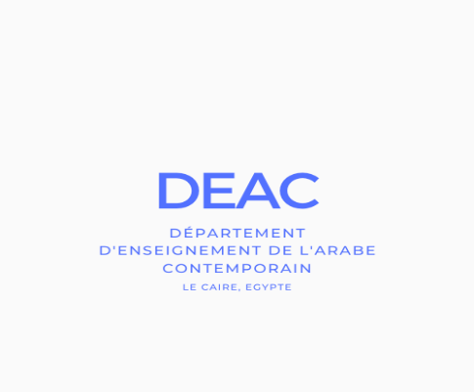
department of contemporary Arabic language

JULY 2020 REMOTE SESSION

From July 1st to July 29th, 2020

Online oral placement tests from June 28th to June 30th, 2020

Individual registration form

to be returned to: deac@ifegypte.com
First/ last name: ……………………………………………..……………..…
Photo
Date & place of birth: …………………………………………..………….…
Nationality: …………………………………………………………………...
Permanent address: ………………………………………………….………
…………………………………………………………………………………
Home phone number: ………………….……
Mobile phone number : ….…………………..………
E-mail : ………………………………………………………..……………….

I wish to subscribe to:
Program 1: Standard modern Arabic (literal Arabic) exclusively
Program 2: Egyptian colloquial Arabic exclusively
Program 3: Standard Modern Arabic and Egyptian colloquial Arabic
Program 4: Specific program to prepare for the French Ministry of Europe and Foreign Affairs recruitment competitive exams (“concours”)
Please fill in accurately
Professional situation: …………………………………………………………..
Studies other than Arabic
University diplomas obtained (place and year, university):
……………………………………………………………………………………………
……………………………………………………………………………………………
Current university (or institution): ………………………………………………………..
Ongoing Main university course……………………………………………………..
Ongoing University diploma:…………………………………………………………..

Arab studies

Number of university years: …………………………………………………………
Weekly volume of Arabic language courses: ……………………………………
hours
CUMULATIVE TOTAL OF YOUR ARABIC LANGUAGE HOURS:
University diplomas obtained in Arabic studies (place, year):
………………………………………………………………
………………………………………………………………
………………………………………………………………
- Do you speak an Arabic dialect? yes no If yes, which one …………....…….
How do you estimate your level in this dialect? …………………………………..…………
- How do you estimate your level of Egyptian dialect?
absolute beginner false beginner post beginner intermediate advanced
- How do you estimate your level of written literal Arabic?
absolute beginner false beginner post beginner intermediate advanced

N.B .: Admitted students to DEAC summer courses agree to pay the registration fees by bank transfer at the latest before the 21st of June 2020 and to send the DEAC by email proof of payment within the same deadlines.
Done at …………………………………… .. On ……………………………………

Signature :

